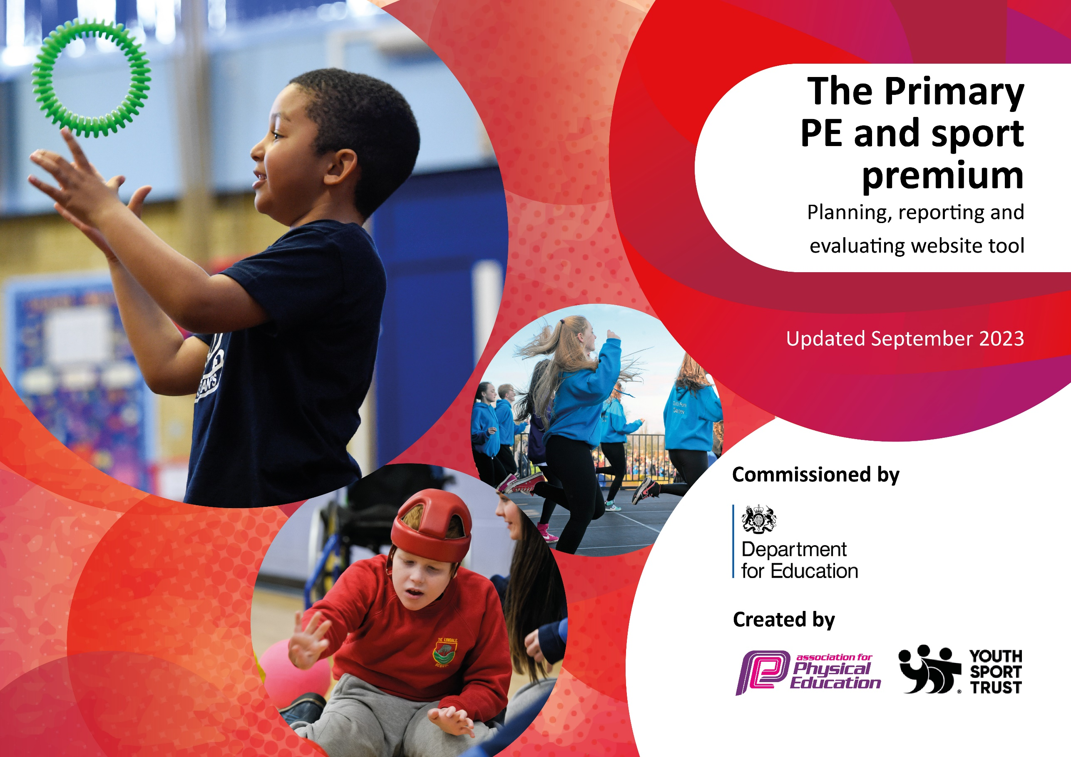

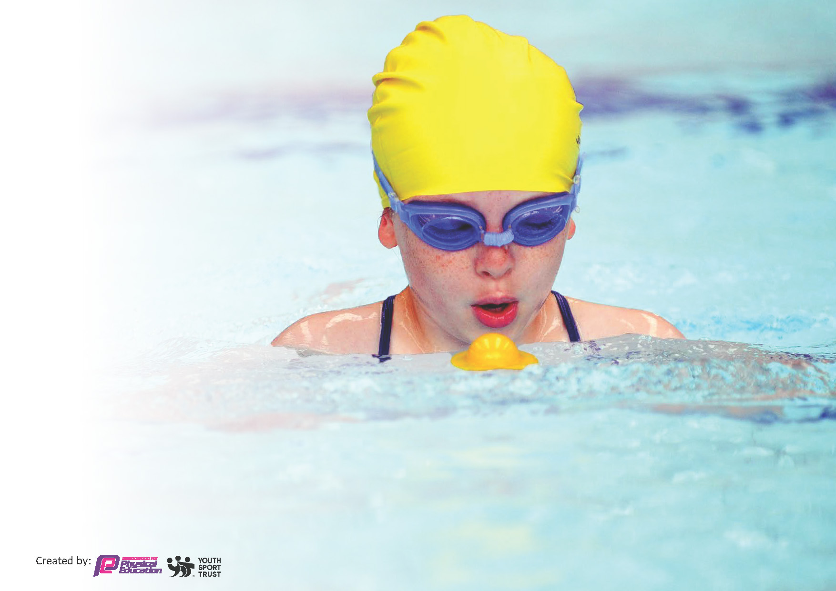
This template can be used for multiple purposes:
by:
- It enables schools to effectively plan their use of the Primary PE and sport premium
- It helps schools to meet the requirements (as set out in guidance) to publish information on their Primary PE and sport premium
- It will be an effective document to support Ofsted inspections enabling schools to evidence progress in Physical Education (PE) and evidence swimming attainment, which forms part of the PE National Curriculum. We would recommend schools consider
the Intent, Implementation and Impact of any spend, as examined within the Education Inspection Framework.

It is important that your grant is used effectively and based on school need.

Schools must use the funding to make additional and sustainable
improvements to the quality of the PE, School Sport and Physical Activity (PESSPA)
they offer. This means that you should use the Primary PE and sport premium to:

- Build capacity and capability within the school to ensure that improvements made now will benefit pupils joining the school in future years
- Develop or add to the PESSPA activities that your school already offers.

The Primary PE and sport premium should not be used to fund capital spend projects; the school’s core budget should fund these. Further detail on capital expenditure can be found in the updated Primary PE and sport premium guidance.

The Primary PE and sport premium guidance, outlines 5 key priorities that funding should be used towards. It is not

necessary that spending has to meet all the key priorities, you should select the priorities that you aim to use any funding towards.

Although completing this template is not a requirement for schools, schools are required to publish details of how they spend this funding. Schools must also outline what the impact this funding has had on pupils’ PE and sport participation and attainment and how any spending will be sustainable in the future. All funding must be spent by 31st July 2024.

The Department for Education has worked closely with the Association for Physical Education (afPE) and the Youth Sport Trust (YST) to develop this template and encourages schools to use it. This template is an effective way of meeting the reporting requirements of the Primary PE and sport premium.
Review of last year’s spend and key achievements (2022/2023)

We recommend you start by reflecting on the impact of current provision and reviewing your previous spend.

Activity/Action | Impact | Comments
Forest School- Leader created curriculum overviews and progress scheme. All children in Reception and Key Stage 1 having one afternoon session weekly.  Participation in partnership and county events has increased due to school taking up partnership sports offer.  Purchase of curriculum scheme- Complete P.E. to enhance full P.E. curriculum offer. | Clear progression of skills and knowledge throughout the groups attending Forest school.  Wider group of children taking part in sporting events and our teams successfully competing against other schools.  Teachers have used the scheme well but some units need revisiting with our own planning. Teacher less confident with teaching P.E. tell us the structure and progression of skills is very helpful. | Pupils gaining independent skills and developing the ability to risk take, problem solve and negotiate tasks with others with growing independence.  Both gross and fine motor skills are being developed with our youngest children.  Evidence indicates that children not keen on sport willing to take part in partnership events due to wider partnership offer. (e.g. Boccia ball)  P.E. Lead will meet teachers termly to review units of work and replace or supplement any units that are not deemed suitable to a particular class.

Key priorities and Planning
This planning template will allow schools to accurately plan their spending.

Action – what are you planning to do | Who does this action impact? | Key indicator to meet | Impacts and how sustainability will be achieved? | Cost linked to the action
Introduce Play Leaders from UKS2 to support with lunchtime activities. | Older children will help engage the younger children with activities at breaktime, helping them be active and developing the lifelong love of sport. | Key indicator 1 -The engagement of all pupils in regular physical activity – the Chief Medical Officer guidelines recommend that all children and young people aged 5 to 18 engage in at least 60 minutes of physical activity per day, of which 30 minutes should be in school. | To keep the Play Leaders scheme going for years to come and potentially investigate further schemes that actively encourage pupils to take on leadership and volunteer roles. | £2000

To identify effective strategies for PE to be used as a tool within other subjects to drive standards and be used to support whole school development-including learning outside the classroom | Children from across the school. | Key indicator 2: The profile of PESSPA being raised across the school as a tool for whole school improvement. | Equipment order encouraging pupils to engage with PE to support confidence with learning across the curriculum. | £1000

To use Complete PE curriculum to support teaching and learning of PE | Teachers to have a scheme of work that they are draw upon to teach P.E. | Key indicator 3: Increased confidence, knowledge and skills of all staff in teaching PE and sport | Teachers gain confidence with teaching a curriculum with clear progression year to year. | Annual subscription £150

To use Forest School to give children a broader range of activities to engage with. | Youngest children in our school (Reception to Year 2). | Key Indicator 4:  Broader experience of a range of sports and activities offered to all pupils. | We have a number of Forest school teachers in school and have appointed an overall Lead teacher.  For the pupils: develops fine and gross motor skill; develops problem solving skills; increase in self confidence and self-esteem. | £5000
Bikeability Cycling Proficiency Programme through the Windrush Bike Project | Year 5 and After school club for those children in Year 2/3 who have yet to learn to ride a bike |  | Pupils gain confidence cycling on roads in a safe manner.  Those pupils taking part in the after school programme are now able to ride a bike. | £500
Swimming for all through use of school swimming pool | All pupils from Reception to Year 6 including life saving course for parents which enables those family with life saving adults the ability to use the school pool outside school hours throughout the summer term and during the summer holidays |  | All children grow in confidence swimming. For those unable to attend swimming sessions due to rural isolation, this gives them an opportunity to learn to swim from an early age. | £4050

To continue to engage in, and further develop children’s participation and attendance at partnership sporting events, sporting festivals and county wide opportunities to continue to develop both sports skills and other team participation values. | All pupils across the school through Burford Partnership and engagement with West Oxfordshire Sports Leaders. | Key Indicator 5:  Increased participation in competitive sport | High levels of participation. Children enjoy Burford partnership competitions, county wide tournaments and locally arranged sporting events. | £4591

Key achievements 2023-2024
This template will be completed at the end of the academic year and will showcase the key achievements schools have made with their Primary PE and sport premium spending.

Activity/Action | Impact | Comments

Swimming Data
Meeting National Curriculum requirements for swimming and water safety.
Priority should always be given to ensuring that pupils can perform safe self-rescue even if they do not fully meet the first two requirements of the National Curriculum programme of study

Question | Stats: | Further context  Relative to local challenges
What percentage of your current Year 6 cohort can swim competently, confidently and proficiently over a distance of at least 25 metres? | % | Use this text box to give further context behind the percentage.  e.g., 30% - we are struggling to get pool space due to our local pool closing so we have had to use a much smaller local school pool. We have had to limit the number of pupils attending swimming lessons during one term which means some pupils have attended fewer swimming lessons than others.
What percentage of your current Year 6 cohort can use a range of strokes effectively [for example, front crawl, backstroke, and breaststroke]? | % | Use this text box to give further context behind the percentage.  e.g., Even though your pupils may swim in another year please report on their attainment on leaving primary school at the end of the summer term 2024

What percentage of your current Year 6 cohort are able to perform safe self-rescue in different water-based situations? | % | Use this text box to give further context behind the percentage.
If your schools swimming data is below national expectation, you can choose to use the Primary PE and sport premium to provide additional top-up sessions for those pupils that did not meet National Curriculum  requirements after the completion of core lessons. Have you done this? | Yes/No
Have you provided CPD to improve the knowledge and confidence of staff to be able to teach swimming and water safety? | Yes/No

Signed off by:

Head Teacher: | Joseph Rubba
Subject Leader or the individual responsible for the Primary PE and sport premium: | Ollie Leader
Governor: | CPP Committee
Date: October 10th 2023 | Planned Review: June 2024

