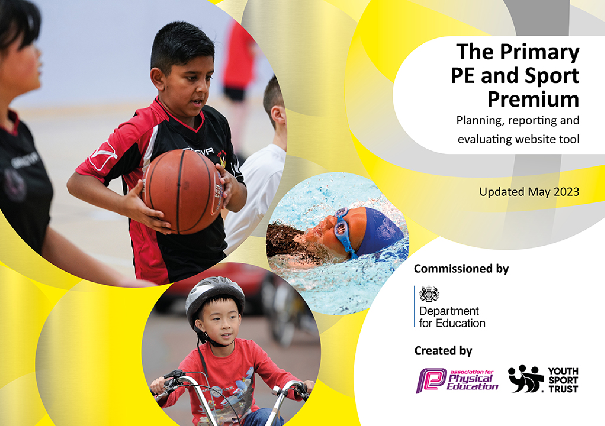

It is important that your grant is used effectively and based on school need. The Education Inspection Framework makes clear there will be a focus on ‘whether leaders and those responsible for governors all understand their respective roles and perform these in a way that enhances the effectiveness of the school’.
Under the Quality of Education Ofsted inspectors consider:
Intent - Curriculum design, coverage and appropriateness
Implementation - Curriculum delivery, Teaching (pedagogy) and Assessment Impact - Attainment and progress
To assist schools with common transferable language this template has been developed to utilise the same three headings which should make your plans easily transferable between working documents.
Schools must use the funding to make additional and sustainable improvements to the quality of Physical Education, School Sport and Physical Activity (PESSPA) they offer. This means that you should use the Primary PE and sport premium to:
- Develop or add to the PESSPA activities that your school already offer
- Build capacity and capability within the school to ensure that improvements made now will benefit pupils joining the school in future years
- The Primary PE and sport premium should not be used to fund capital spend projects; the school’s budget should fund these.
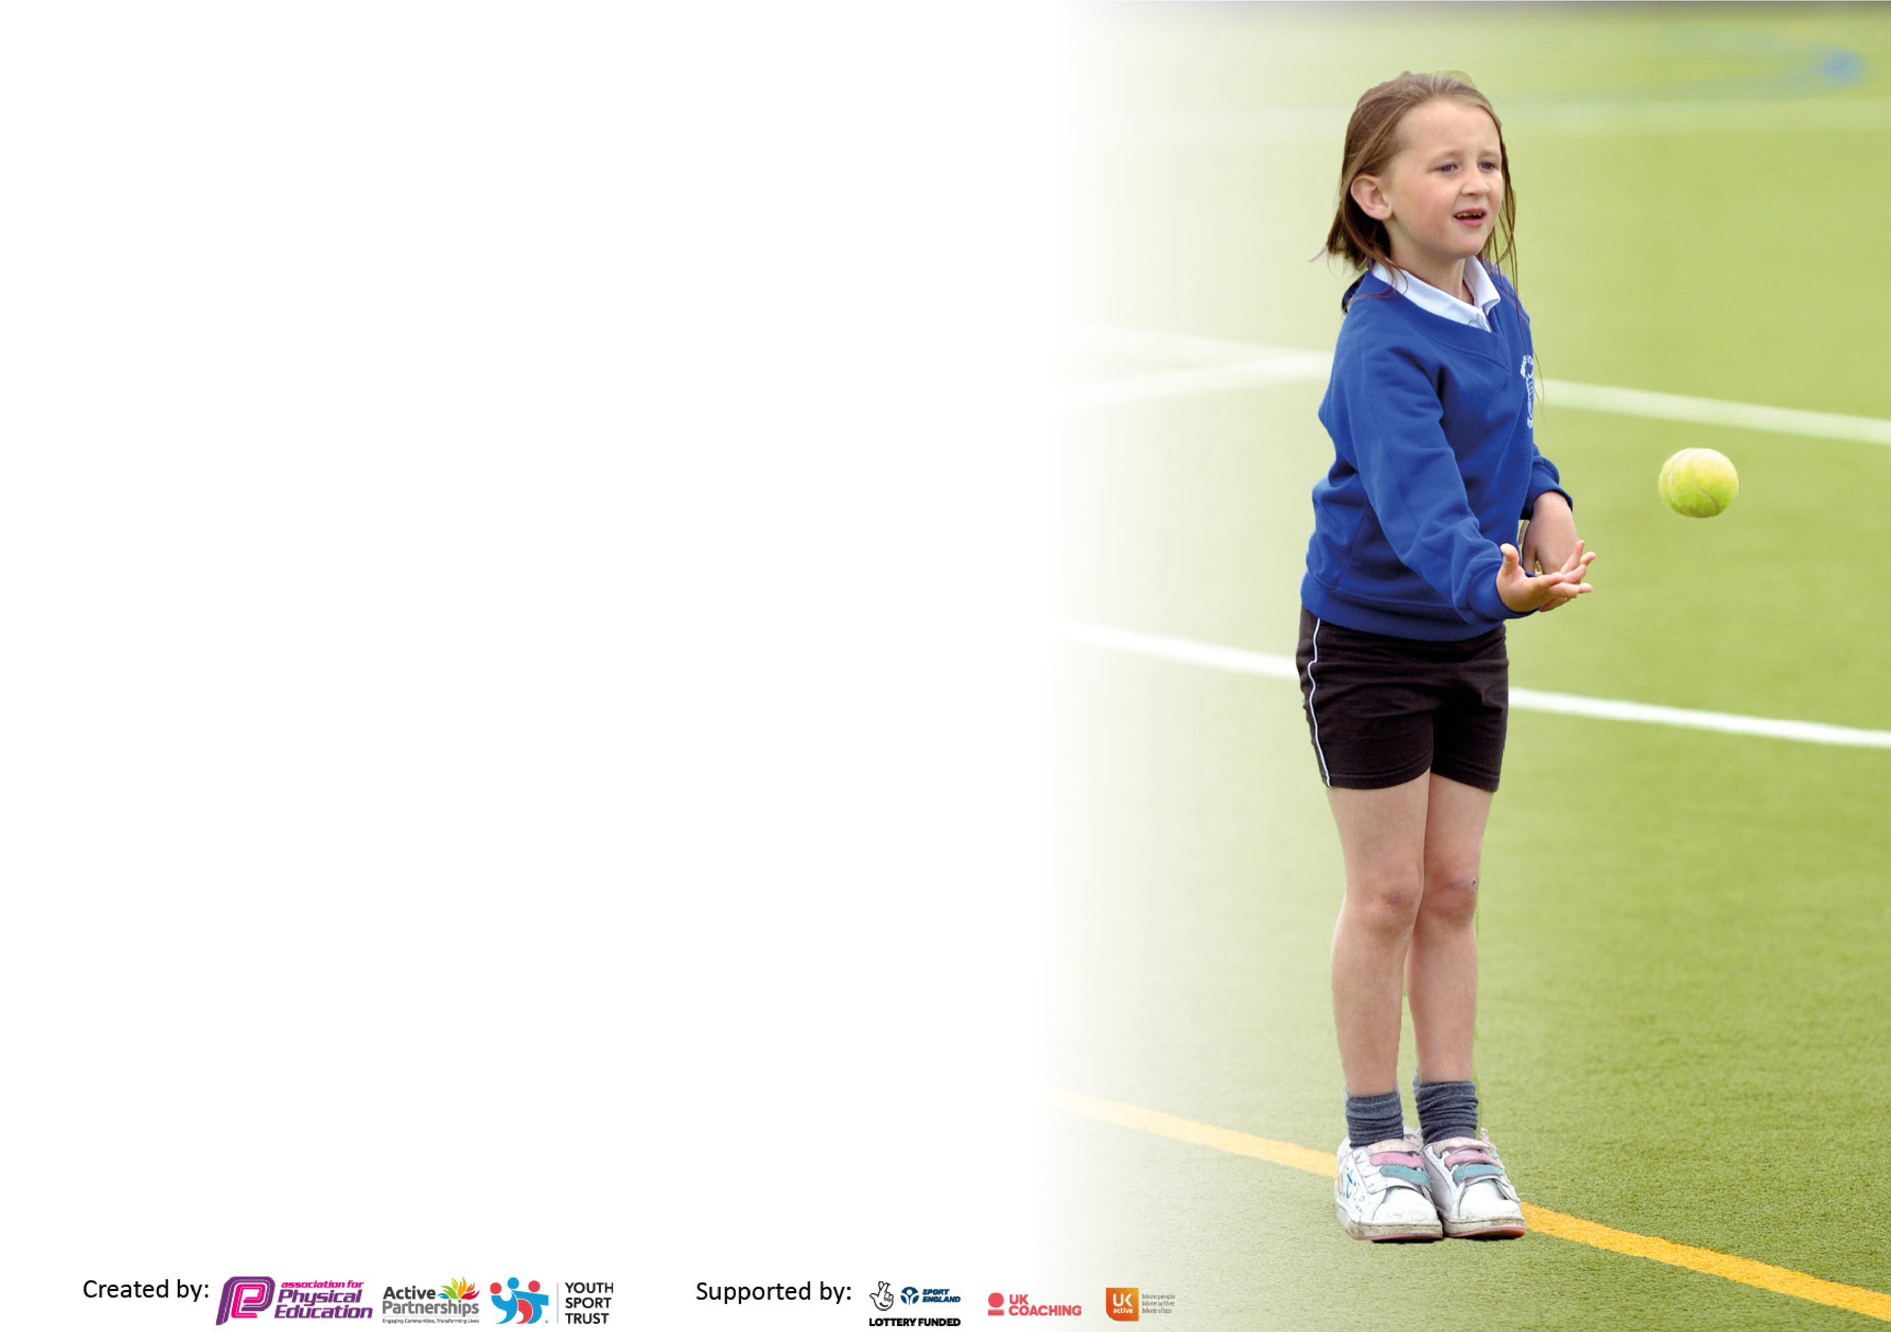
Pleasevisitgov.ukfortherevisedDfEguidanceincludingthe5keyindicatorsacrosswhichschoolsshoulddemonstrate animprovement.Thisdocumentwillhelpyoutoreviewyourprovisionandtoreportyourspend.DfEencouragesschools to use this template as an effective way of meeting the reporting requirements of the Primary PE and Sport Premium. We recommend you start by reflecting on the impact of current provision and reviewing the previous spend.
Schools are required to publish details of how they spend this funding, including any under-spend from 2021/2022, as well as on the impact it has on pupils’ PE and sport participation and attainment. All funding must be spent by 31st July 2023.
We recommend regularly updating the table and publishing it on your website throughout the year. This evidences your ongoing self-evaluation of how you are using the funding to secure maximum, sustainable impact. Final copy must be posted on your website by the end of the academic year and no later than the 31st July 2023. To see an example of how to complete the table please click HERE.
Details with regard to funding
Please complete the table below.

Total amount carried over from 2021/22 | £0
Total amount allocated for 2021/22 | £18,629
How much (if any) do you intend to carry over from this total fund into 2022/23? | £0
Total amount allocated for 2022/23 | £18,578
Total amount of funding for 2023/23. To be spent and reported on by 31st July 2023. | £18,578

Swimming Data
Please report on your Swimming Data below.

Meeting national curriculum requirements for swimming and water safety.  N.B. Complete this section to your best ability. For example, you might have practised safe self-rescue techniques on dry land which you can then transfer to the pool when school swimming restarts.  Due to exceptional circumstances priority should be given to ensuring that pupils can perform safe self-rescue even if they do not fully meet the first two requirements of the NC programme of study | -
What percentage of your current Year 6 cohort swim competently, confidently and proficiently over a distance of at least 25 metres?  N.B. Even though your pupils may swim in another year please report on their attainment on leaving primary school at the end of the summer term 2023. Please see note above | 100%
What percentage of your current Year 6 cohort use a range of strokes effectively [for example, front crawl, backstroke and breaststroke]?  Please see note above | 100%
What percentage of your current Year 6 cohort perform safe self-rescue in different water-based situations? | 100%
Schools can choose to use the Primary PE and Sport premium to provide additional provision for swimming but this must be for activity over and above the national curriculum requirements. Have you used it in this way? | Yes

Action Plan and Budget Tracking
Capture your intended annual spend against the 5 key indicators. Clarify the success criteria and evidence of impact that you intend to measure to evaluate for pupils today and for the future.

Academic Year: 2022/23 | Total fund allocated: £18,578 | Date Updated: 26.06.23
Key indicator 1: The engagement of all pupils in regular physical activity – Chief Medical Officers guidelines recommend that primary school pupils undertake at least 30 minutes of physical activity a day in school |  |  |  | Percentage of total allocation:  27%
Intent | Implementation |  | Impact | Sustainability & Action Planning
Your school focus should be clear what you want the pupils to know and be able to do and about what they need to learn and to consolidate through practice: | Make sure your actions to achieve are linked to your intentions: | Funding allocated: | Evidence of impact: what do pupils now know and what can they now do?  What has changed? | Sustainability and suggested next steps:
Forest School  Developing fine and gross motor skills with our youngest children.  Increase in self confidence and self-esteem.  Developing problem solving and teamwork skills | Fully fund Forest School Lead in KS1 and TA to lead Outdoor Learning provision alongside teacher and support staff.  Weekly Forest School sessions provided to pupils in EYFS and KS1.  Materials for outdoor learning. | £5200 | Children gaining independent skills and developing the ability to risk take, problem solve and negotiate tasks with others independently. | To consider the use of Forest School after school for older children who no longer have weekly sessions.

Key indicator 2: The profile of PESSPA being raised across the school as a tool for whole school improvement |  |  |  | Percentage of total allocation:  6.5%
Intent | Implementation |  | Impact | Sustainability & Action Planning
Your school focus should be clear what you want the pupils to know and be able to do and about what they need to learn and to consolidate through practice: | Make sure your actions to achieve are linked to your intentions: | Funding allocated: | Evidence of impact: what do pupils now know and what can they now do? What has changed? | Sustainability and suggested next steps:
Using a range of new equipment (and updating older equipment) to motivate and encourage skills development. | New tennis nets, net ball posts and equipment for invasion games were some of the updated purchases for PE | £1200 | Enhancement of curriculum due to purchased equipment used in lessons. | To expand our unit on International games and more modern games in the summer term.

Key indicator 3: Increased confidence, knowledge and skills of all staff in teaching PE and sport |  |  |  | Percentage of total allocation:  4.6%
Intent | Implementation |  | Impact | Sustainability & Action Planning
Your school focus should be clear what you want the pupils to know and be able to do and about what they need to learn and to consolidate through practice: | Make sure your actions to achieve are linked to your intentions: | Funding allocated: | Evidence of impact: what do pupils now know and what can they now do? What has changed? | Sustainability and suggested next steps:

To increase staff knowledge and confidence around the delivery of a high quality PE curriculum, and how it can help promote healthy and active lifestyles, and improve mental health and wellbeing | Lead staff meetings and organise ongoing programmes of support,  including team-teaching and peer observations. | £750 | Staff feel more confident at delivering high-quality PE sessions; children’s engagement is high and children can talk about their enjoyment of sport &  PE. | Audit staff skill and confidence level to inform future staff CPD and development opportunities.
To improve the teaching of PE we have invested in a curriculum package which we pay an annual subscription. | PE lead to monitor the use of PE curriculum | Annual subscription- £105 | A more varied PE offer is now in place for pupils and skills and knowledge are taught in a more systematic manner building on pupils’ prior knowledge and skill. | Look for assessment opportunities for each unit covered.

Key indicator 4: Broader experience of a range of sports and activities offered to all pupils |  |  |  | Percentage of total allocation:  32.6%
Intent | Implementation |  | Impact | Sustainability & Action Planning
Your school focus should be clear what you want the pupils to know and be able to do and about what they need to learn and to consolidate through practice: | Make sure your actions to achieve are linked to your intentions: | Funding allocated: | Evidence of impact: what do pupils now know and what can they now do? What has changed? | Sustainability and suggested next steps:
Bikeablilty Cycling Proficiency Programme  Children learn to cycle safely in public places. (Year 5)  After school Club for those children in Year 2/3 who have yet to learn to ride a bike. | Windrush Bike Project lead our training. | £1100 | Pupils gain confidence cycling on roads in a safe manner.  Those who took part in our after school club are now able to ride a bike. | Parents and carers tell us that they want the programme delivered earlier in the year as many of the Year 5 pupils are riding their bikes to school. As a result, we are trying to schedule the programme for the Autumn term.
Swimming for all pupils  We would like to deliver weekly swimming lessons to every pupil across the school using our own pool.  We would like to provide life saving course for parents to enable them to use the pool outside of school hours, increasing activity time for pupils throughout the term and summer holidays. | Pool needed servicing.  Lifesavers course for staff to enable every class to swim.  Employ swimming teachers to lead lessons. | £4975 | On the whole, every class went swimming weekly which gave the youngest ones valuable experience of being in the pool. | Look at training our own staff to lead swimming as timetabling was challenging due to teachers’ own timetables.

Key indicator 5: Increased participation in competitive sport |  |  |  | Percentage of total allocation:  24.7%
Intent | Implementation |  | Impact | Sustainability & Action Planning
Your school focus should be clear what you want the pupils to know and be able to do and about what they need to learn and to consolidate through practice: | Make sure your actions to achieve are linked to your intentions: | Funding allocated: | Evidence of impact: what do pupils now know and what can they now do? What has changed? | Sustainability and suggested next steps:
Partnership Offer  Retention and development of the successful sports programme within the Burford Partnership of Schools  - Partnership school sports coordinator retained  - Training for PE lead teachers | Children are taking part in partnership events in all year groups led by the Partnership School Sports Coordinator.  They also led ‘new sports’ e.g. Tri-golf for the whole school. | £4591 | Pupils participated in a range of sport competitions this year. Wychwood won 85% of the events entered including making it to the county finals in Cricket, Quad Kids and Cross Country Running. | To ensure that the PE lead organising events into ‘competitive and participation’ enabling more pupils to take part across the school.

Signed off by
Head Teacher: | Joseph Rubba
Date: | 27.6.23
Subject Leader: | Ollie Leader
Date: | 27/6/23
Governor: CPP | CPP Committee
Date: | October 10th 2023

