Wychwood CE Primary School
After School Provision (WASP)



Information and Terms and Conditions May 2025

Wychwood CE Primary School (Ref: 123176)
Milton Road
Shipton under Wychwood
Chipping Norton
Oxfordshire
OX7 6BD
Tel: 01993 830059
WASP Tel: 01993 463757
WASP Email: WASP@wychwood-pri.oxon.sch.uk
Information

We are pleased to be offering both Breakfast Club and After School Provision (WASP). At the moment we will be offering term time only and some INSET days care for children in Years Reception-6.

Hours and Location
- Breakfast Club - 7:30-8:30
- After School - 3:15-6:00 (5.00pm when school finishes for the term at 1.30pm)
- INSET Days 8:00-5:00

Parents can collect children from the playground, entering through the Learning Zone door.

ChildCare Vouchers

Our Wrap Around care is registered with the Government Voucher Scheme.
If you are looking to use Childcare Vouchers we are registered with the following:
- Kiddivouchers: Put in the school postcode OX7 6BD to find our school
- Computershare: 0026406092
- Care4: 06601536
- EdenRed: P21248716
- Sodexo: 902549
- The Government Scheme: 50004708482
- RG Childcare: 72051159808
- Fair Care Childcare Vouchers: WYCH0822

Please could you mark on your registration form which providers you use.

Booking Sessions

Bookings for WASP are made through Parent Pay. This is the system we use for paying for trips and other school related costs. We offer 2 rates depending on whether you pre-book your sessions or want to make last minute ‘Adhoc’ bookings. Any booking made 2 weeks or more before the session can be booked on the pre-booked system to receive the cheaper rate. Within 2 weeks you will need to use the Adhoc system.

You will need to let Mrs Coombes know if you will be using childcare vouchers to pay as this will decide which booking forms you are allocated to.

Voucher Users
If you pay using vouchers you will not be able to do this through Parent Pay. You will be able to book your sessions without paying. The School Office will then invoice you on a fortnightly basis for all the sessions that you child has taken. You will be able to make payments as you have done in the past to the usual school bank account.
Non-voucher Users
If you don’t use vouchers, you will need to pay as you book sessions. We will not send you any invoices.

Pre-Booked Charges (For any sessions booked 2 weeks in advance)
Breakfast Club - £7.00 (to include breakfast)
1:30 – 3:30 (Last day of a long term only): £5.00
3:15 – 4:15: £6.50
4:15 – 6:00 (Includes a light tea): £8.50 – this session will only run when after school clubs are running)
3:15 – 6:00 (Includes a light tea): £11.00

Ad-Hoc Sessions
After School Ad-hoc sessions can be booked up until 9.30 on the day of booking, while Breakfast Club bookings can be made until 7am on the day. Please give 24 hours’ notice if tea is required. These will be charged at the following rates:
Breakfast Club - £7.00 (includes breakfast)
1:30 – 3:30 (Last day of a long term only): £5.00
3:15 – 4:15: £8.50
4:15 – 6:00 (includes a light tea): £10.50
3:15 – 6:00 (Includes a light tea): £13.00

If your child is at a club we can collect them at 4.15 for them to join WASP for the rest of the session. You will need to book the session from 4.15 rather than 3.15 if your child is booked for a club.

After 9.30 on the day, please email: WASP@wychwood-pri.oxon.sch.uk for any last minute availability, or telephone the school office.

Parent Pay Instructions

To find the WASP session on your Parent Pay account there is a drop-down list that includes clubs.

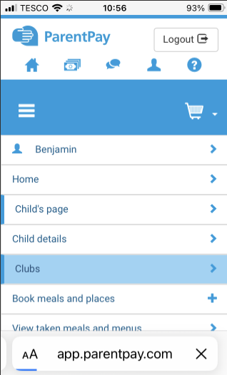

On laptops this is after clicking on the round child icon in the top left-hand corner with the child’s name. On mobiles it appears when you click the 3 lines on the top left.
Once you have clicked on this you should have 4 options for booking:- Breakfasts, After school Pre-booked, After school Adhoc and Inset Days. Pre-booked sessions need to be booked 2 weeks in advance. All other sessions will need to be booked as Adhoc sessions. For Breakfasts there is only one charge (and bookings can be made up to 7am on the day of booking). Choose ‘View Club’ for the type of session you want to book:

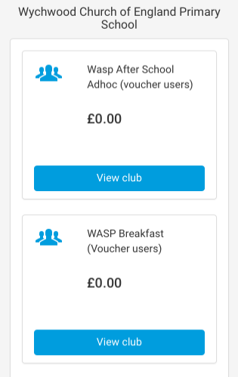

This will then bring up the screen where you can choose the dates you wish to book. You will need to book all type of sessions (for example, if you want five 3-6pm sessions you can select them all in one go. You will need to select 3-4.15 sessions separately).

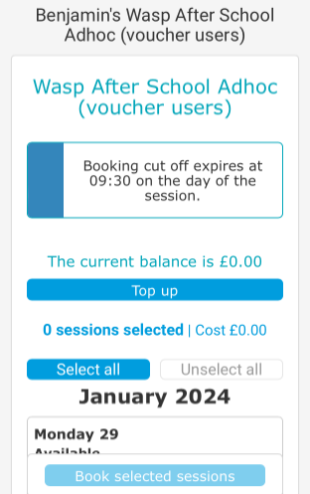

When you have selected the dates you will be asked to choose which session you wish to book (on the after school session not the breakfast one – there is only one price for Breakfasts).
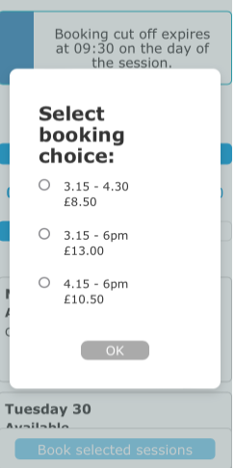

Once you have selected the session you require and have clicked OK the date you have selected will turn orange and you will be able to see which booking choice you made.

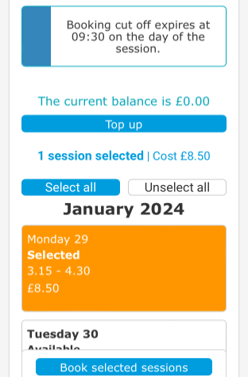

You can then go through and book as many sessions as you wish.
If you are a voucher user you will be able to complete your booking without making a payment.

After School Clubs
If your child has an after-school club (eg choir, football etc) you will be able to select the 4.15 – 6pm session. As clubs are announced in advance, you will be able to select the correct session yourself when booking WASP care. The WASP manager will still manage last minute changes (for example if a club is cancelled one week), however will not be making routine changes to 3.15 bookings when a club is being attended.

Extending Pre-booked sessions
If you want to extend a pre-booked 4.15 session to a 6pm session after the 14-day cut off, you will need to email the WASP Manager – WASP@wychwood-pri.oxon.sch.uk. Your account will be charged the additional £4.50 fee (the difference between the Pre-booked 4.15 rate and the Pre-booked 6pm rate).

For voucher users, this will be reflected in your fortnightly invoice. For non-voucher users you will need to top up your account on Parent Pay to cover the charge.

Our Terms

- Terms

What do these terms cover? These are the terms and conditions on which we (Wychwood CE Primary School) supply childcare services to you.

Why you should read them? Please read these terms carefully before you complete the Registration Form and return it to us. These terms tell you who we are, how we provide services to you, how you and we may change or end the service, what to do if there is a problem and other important information. If you think that there is a mistake in these terms, please contact us to discuss before you sign the registration form.

- Information about us and how to contact us

Who we are: Wychwood After School Provision (WASP)

How to contact us: You can contact us by telephoning us direct on 01993 463757 or telephoning the school office on 01993 830059. Alternatively you can send an email to WASP@wychwood-pri.oxon.sch.uk. Our postal address is: Wychwood CE Primary School Milton Road, Shipton under Wychwood, Chipping Norton, Oxfordshire, OX7 6BD, UK.

How we may contact you: If we have to contact you, we will do so by telephone or email you provided with your registration form.

- Our agreement with you

How to secure a place? To secure a place a parent or carer will need to complete a registration form and once we confirm (via email) that we have availability you may proceed with bookings.

- Our rights to make changes

Changes to the service we provide: We may change the service we provide:
- To reflect changes in relevant laws and regulatory requirements.
- To implement minor technical adjustments and improvements.

We are not responsible for delays or disruption outside our control: If our ability to deliver childcare is affected by an event outside our control then we will contact you as soon as possible to let you know and we will take steps to minimise the impact of the delay or the disruption. Provided we do this, we will not be liable for delays or disruption caused by the event, but if there is a risk of substantial delay or disruption you may contact us to end the agreement and receive a refund for any services you have paid for but not received.

We may have to suspend any service to:
- Deal with technical problems or make minor technical changes;
- Update services to reflect changes in relevant laws and regulatory requirements;
- Make changes to the services as requested by you or notified by us.

Your rights if we suspend the services: We will contact you in advance to tell you we will be suspending the services, unless the problem is urgent or an emergency. If we have to suspend the services, we will adjust the price so that you do not pay for services while they are suspended.

We may also suspend services if you do not pay: For Voucher users who are invoiced - If you do not pay for the services as outlined in the Information Letter and you still do not make payment within 14 days of the original date that the payment is due, we may suspend supply of the service until you have paid the outstanding amount. We will contact you to tell you we have not received payment. Following that we will write to tell you we are suspending supply of the services. We will not suspend the services where you dispute the unpaid invoice. We will not charge you for the service during the period for which they are suspended.

- Our rights to end the agreement

We may end the agreement if:
- You do not make any payments when it is due and you still do not make payment within one month of us notifying you that payment is due;
- You do not, within a reasonable time of us asking for it, provide us with information that is necessary for us to provide a safe service;
- Your child’s behaviour is such that we cannot ensure the safety of them or others that use the service.

If we end the agreement in any of the situations outlined in 5, we will refund any money you have paid in advance for services we have not provided.

- If there is a problem

If you have any questions or complaints about WASP: Please contact us by telephoning the school office on 01993 830059 or by email at WASP@wychwood-pri.oxon.sch.uk

- How we may use your personal information

We will use the personal information you provide us to:
- Provide the services to the best of our ability;
- Process your payment for such services

We will only give your personal information to third parties where the law requires us to do so.

Annex 1

Arrangements for collection of children: We require that all children be signed out by their parent/carer. We will allow collections by any adult listed as an emergency contact for your child (by the school). If your child is being collected by someone other than a regular contact please let us know in advance. In this case we may ask for photo identification.

Arrangements for late collections: If you anticipate that you may be late collecting your child, please contact the WASP manager (Claire Coombes) by ringing the WASP mobile number. If you collect your child after the agreed time, a late fee of £5 will be charges for every 15 minutes or part of 15 minutes after the closure of the provision. If a child has not been collected by 7p.m. and we have not been able to contact the parent/carers or emergency contacts, then the MASH team will be contacted.

Absences: If your child is absent from school due to illness, they may not attend WASP. If your child is not coming on a particular day for any reason, we would appreciate you letting us know by 8 a.m. that day. You may contact us by leaving a message with the school’s office staff or by leaving a voice mail message on the WASP mobile. Please note that you will still be charged for your child’s place. If your child is off because of a long-term illness (of more than two days) a credit will be issued on Parent Pay, which you can use for future bookings.

Providing and keeping up to date contact information: It is the responsibility of the parent/carer to inform the school office or the WASP manager if any information on the registration form needs to be updated. Please ensure that the people listed on the emergency contact information the school holds are contactable during WASP hours.

Illness, injury and medications: If your child becomes ill while in our care, we will contact you and ask that they be collected. You will be notified immediately if your child sustains a significant injury. If immediate medical assistance is deemed necessary, we will contact the appropriate medical personnel and then contact you immediately. If your child suffers a scrape or small cut, we will make you aware of it when you come to pick up your child. Any child who requires medication during the day must have the medication in the original bottle or container that is labelled as to what the medication is and its expiry date, as well as the amount to be taken and how often. All medications must be brought to the School Office and parents will be asked to fill out a medication form regarding its administration.

Behaviour Policy: We will strive to establish a positive atmosphere of mutual respect where children and staff feel valued and secure. We follow the school’s Behaviour Policy where all children are expected to ‘Be Ready, Respectful and Safe.’ Regular deviations from these will result in the need for a conference with parents/carers to determine a plan of improvement. If serious incidents occur or persistent poor behaviour is evident over time, exclusion from WASP may be necessary.

WASP at the end of school terms: On days when there is a half day, WASP will begin at the early dismissal time and end at 5.00 p.m. These half day closing extended hours are included in the fees.

Snacks: As part of looking after the wellbeing of all the children, WASP supports the schools’ Healthy Eating initiatives. We provide a nutritious light breakfast to start the day. Breakfast includes a choice of cereals, toast and/or fruit. A drink of orange juice or milk is provided. For after school we provide a nutritious light snack at 4:30 p.m. These include toast, bagels, wraps, yoghurt and fruit. Children have free access to water throughout all our sessions. Please be sure to note any dietary needs your child may have when registering for WASP.

WASP Registration Form

Child’s name(s): | Date(s) of birth:

Please note: We will use the information held by the school for your child’s details including emergency contacts. If there are any contacts held by the school that you do not wish WASP to contact, please let us know.

Parent’s name(s)
Email address(es) for WASP Communications (including invoicing):
Will you be using vouchers to pay for care (including government tax free payments)? |  | Yes / No (please circle)
If yes, please indicate which provider you use.
Please let us know any special dietary requirements.

I undertake to inform the WASP Manager as soon as possible of any change in medical and/or any other relevant circumstances.

I have read the terms and conditions.

Signed; Parent/Carer: …………………………………………………..Date: ……………………………...……

